**Chapter 7 - QUIZ – IP Addressing Services**

1. Which two statements are true about the DHCP server functions? (Choose two.)
2. When a client requests an IP address, the DHCP server searches the binding table for an entry that matches the MAC address for the client. If an entry exists, the corresponding IP address for that entry is returned to the client.
3. Clients can be assigned an IP address from a predefined DHCP pool for a finite lease period.
4. DHCP services must be installed on a dedicated network server to define the pool of IP addresses available to the clients.
5. The DHCP server can answer requests and assign IP addresses for a particular subnet only.
6. Each subnet in the network requires a dedicated DHCP server to assign IP addresses to the host on the subnet.
7. The DHCP server provides clients with an IP address, subnet mask, default gateway, and domain name.
8. Refer to the following command to answer the question.

What does the string 10.10.10.0 used after the **ip dhcp pool** command specify?

C:\CISCO_CCNA\Exploration4English\courses\en1400000000\en1407000000\en1407060000\en1407060100\en1407060101\cm6921524731\16285.jpg

1. Name of the DHCP pool.
2. Pool of IP addresses available for lease.
3. Range of excluded IP addresses.
4. IP subnet where the DHCP server resides.
5. Which three statements about DHCP are true? (Choose three.)
6. DHCP uses UDP.
7. The DHCP OFFER message is sent by the DHCP server after receiving a DHCP DISCOVER message from a client.
8. DHCP uses ports 67 and 68.
9. The DHCP REQUEST message is sent by a DHCP client to locate a DHCP server.
10. The DHCP ACK message is sent by the DHCP server to provide the DHCP client with the DHCP server MAC address for further communication.
11. All DHCP communications are broadcast.
12. Refer to the following topology description and partial show run output to answer the question. Router R2 is configured as a DHCP server. What would happen when host A sends a DHCP request to the DHCP server?

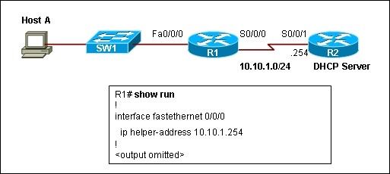

1. The request is dropped by router R1.
2. The request is forwarded to the DHCP server.
3. The request is forwarded to the DHCP server, but the DHCP server does not respond with an IP address.
4. Router R1 responds with an IP address.
5. Refer to the following command output to answer the question. Based on the output, which statement is true regarding this DHCP exchange?

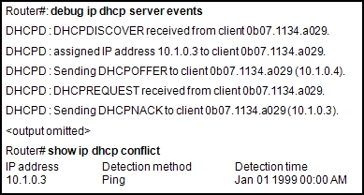

1. The client was successfully configured with the address 10.1.0.3.
2. The DHCP server offered the address 10.1.0.3 to the client.
3. The client requested 10.1.0.3 from the server.
4. The DHCP server could not ping 10.1.0.3.
5. Refer to the following command output to answer the question. Based on the output, which statement is correct concerning the NAT configuration?

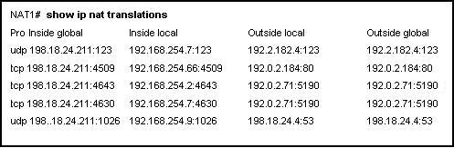

1. Static NAT is configured.
2. Dynamic NAT is configured.
3. PAT is configured.
4. NAT is incorrectly configured.
5. If an administrator chooses to avoid using NAT overload, what is the default timeout value for NAT translations?
6. 1 hour
7. 1 day
8. 1 week
9. Indefinite
10. Match each characteristic on the left to the corresponding NAT technique on the right.

|  |  |  |  |  |  |  |
| --- | --- | --- | --- | --- | --- | --- |
| A. | Provides one-to-one fixed mappings of local and global addresses. | 🡺 |  | | Static NAT | |
| B. | Assigns the translated addresses of IP hosts from a pool of public addresses. | 🡺 |  | | Dynamic NAT | |
| C. | Can map multiple addresses to a single address of the external interface. | 🡺 |  | | NAT with Overload | |
| D. | Assigns the unique source port number of an inside global address on a session-by-session basis. | 🡺 |  | | NAT with Overload | |
| E. | Allows external hosts to establish a session with an internal host. | 🡺 |  | | Static NAT | |
| F. | Defines translations on a host-to-host basis. | 🡺 | | Dynamic NAT | |

1. Refer to the following command output to answer the question. Which host or hosts will have their addresses translated by NAT?

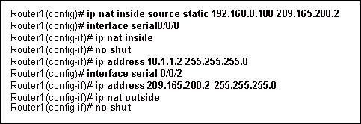

1. 10.1.1.2
2. 192.168.0.100
3. 209.165.200.2
4. All hosts on the 10.1.1.0 network
5. All hosts on the 192.168.0.0 network
6. Refer to the following command output to answer the question. Which addresses will be translated by NAT?

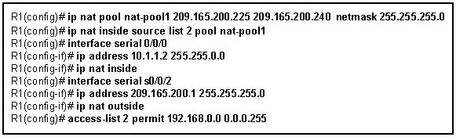

1. 10.1.1.2 to 10.1.1.255
2. 192.168.0.0 to 192.168.0.255
3. 209.165.200.240 to 209.165.200.255
4. Only host 10.1.1.2
5. Only host 209.165.200.255
6. Refer to the following topology description to answer the question. Web Server 1 is assigned a single IP address of 192.168.14.5/24. For hosts from the Internet to access Web Server 1, which type of NAT configuration is required on Router1?

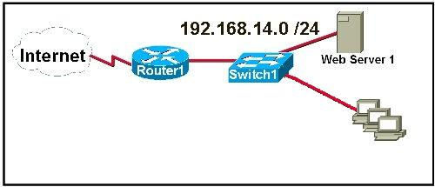

1. Static NAT
2. Dynamic NAT
3. NAT overload
4. Port forwarding
5. Which NAT solution allows external users to access an internal FTP server on a private network?
6. Dynamic NAT
7. NAT with overload using an address pool
8. NAT with overload using an address of the outside interface
9. Port forwarding
10. Refer to the following command output to answer the question.

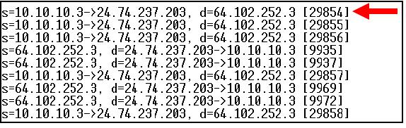

1. Inside local
2. Inside global
3. Outside local
4. Outside global
5. Which two statements accurately describe the RIP n g routing protocol? (Choose two.)
6. RIPng has a limit of 15 hops.
7. RIPng is a link-state routing protocol.
8. RIPng uses UDP port 238 for updates.
9. RIPng uses poison reverse.
10. RIPng forwards IPv6 broadcasts.
11. Which two methods of assigning an IPv6 address to an interface are automatic and can be used in conjunction with each other? (Choose two.)
12. DHCPv6
13. Stateless auto-configuration
14. EUI-64
15. Static assignment
16. DNS
17. Match the IPv6 command on the left to the appropriate descriptionon the right.

|  |  |  |  |  |
| --- | --- | --- | --- | --- |
| A. | **ipv6 unicast-routing** | 🡺 |  | Enables IPv6 traffic-forwarding between interfaces on the router. |
| B. | **ipv6 address** | 🡺 |  | Configure a global IPv6 address. |
| C. | **ip name-server** | 🡺 |  | Specifies the DNS server used by the router. |
| D. | **ipv6 host name** | 🡺 |  | Defines a static hostname-to-address mapping. |
| E. | **ipv6 router rip** *name* | 🡺 |  | Enables RIP n g routing on the router and identifies the RIP process. |

1. Refer to this IPv6 address: **2031:0000:0300:0000:0000:00C0:8000:130B**   
   Which three items are equivalent representations of the full IPv6 address? (Choose three.)
2. 2031:300::C0:8:130B
3. 2031:0:300::C0:8000:130B
4. 2031:1:0:3::C0:8000:130B
5. 2031:0:0300:0:0:C0:8000:130B
6. 2031::300:0:0:0C0:8000:130B
7. 2031::0300::C0:8::130B